Intermediate Holding company

**Financial**

* Market value risk (interest rate risk, exchange prices, equity prices, commodity prices, etc.)
* Credit risk (downgrade, default, credit spread risk)
* Liquidity risk

**Non-Financial:**

* Model Risk
* Operational Risk (fraud, misconduct, failure of internal controls or audit systems, natural disasters)
* Settlement risk
* Accounting risk (changes in GAAP/IFRS and comparability issues, managed earnings, etc.)
* Regulatory risk
* Legal risk (counterparty does not honor a contract)
* Tax risk
* Sovereign risk (if you are trading EM debt for example) & Political risk
* Performance netting risk
* Key Man risk

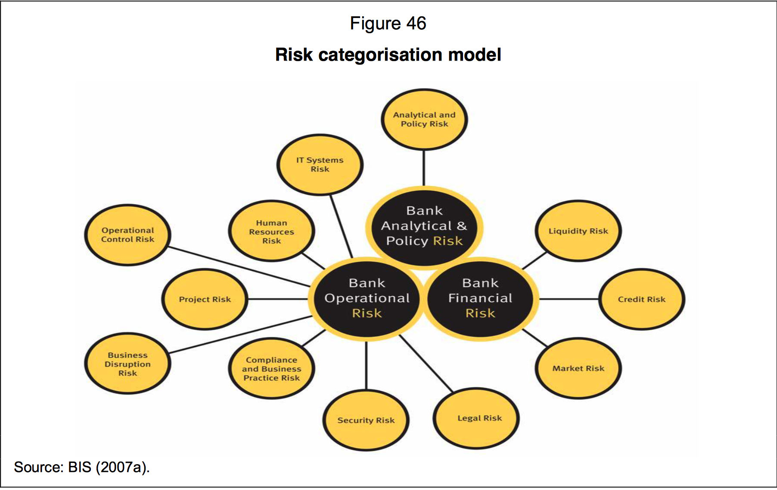

Understanding of Treasury report

**Liquidity Coverage Ratio**

The liquidity coverage ratio (LCR) refers to highly liquid assets held by financial institutions in order to meet short-term obligations. The Liquidity coverage ratio is designed to ensure that financial institutions have the necessary assets on hand to ride out short-term liquidity disruptions.

**LCR= High-quality Liquid Asset (HQLA) amount**

**Total net cash outflow amount**

**The liquidity coverage ratio** (LCR) refers to highly liquid assets held by financial institutions in order to meet short-term obligations. The Liquidity coverage ratio is designed to ensure that financial institutions have the necessary assets on hand to ride out short-term liquidity disruptions. Banks are required to hold an amount of highly liquid assets, such as cash or [Treasury bonds](http://www.investopedia.com/terms/t/treasurybond.asp), equal to or greater than their [net cash](http://www.investopedia.com/terms/n/net-cash.asp) outflow over a 30-day period

**General Ledger Reconciliation**

Reconciling the bank account by comparing your bank statement to the General Ledger accounts ensures the account is in balance for the reconciliation period.